1. Create a windows 2019 Vm with Ds1-V2 standard

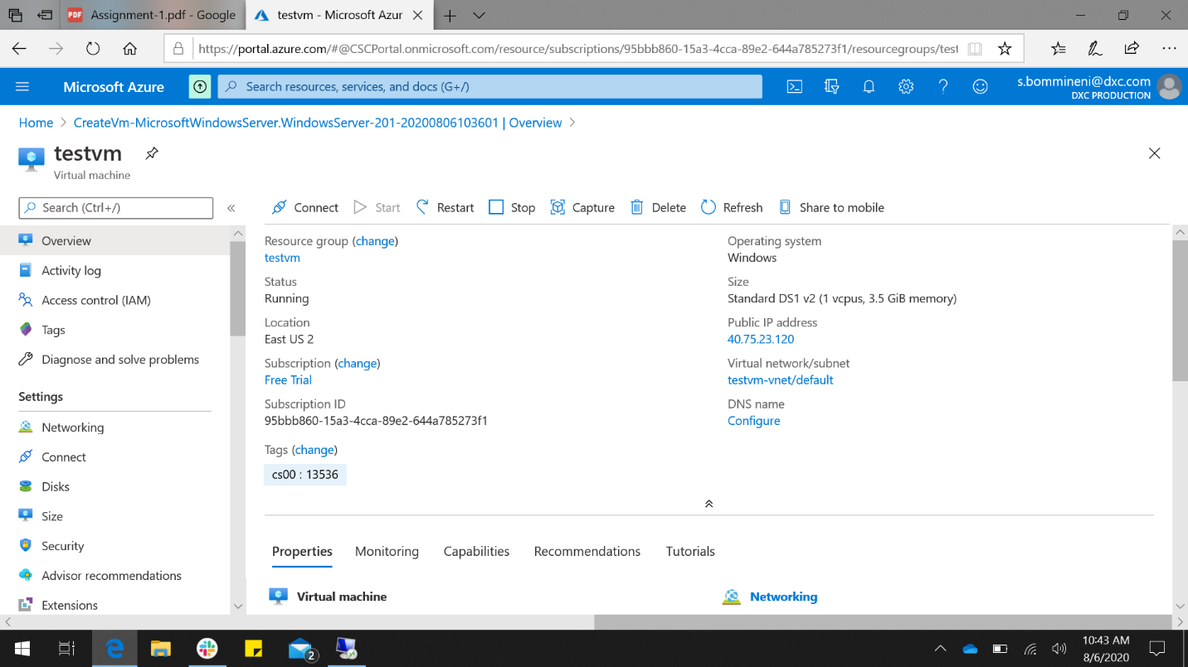

I have created server 2019 data center

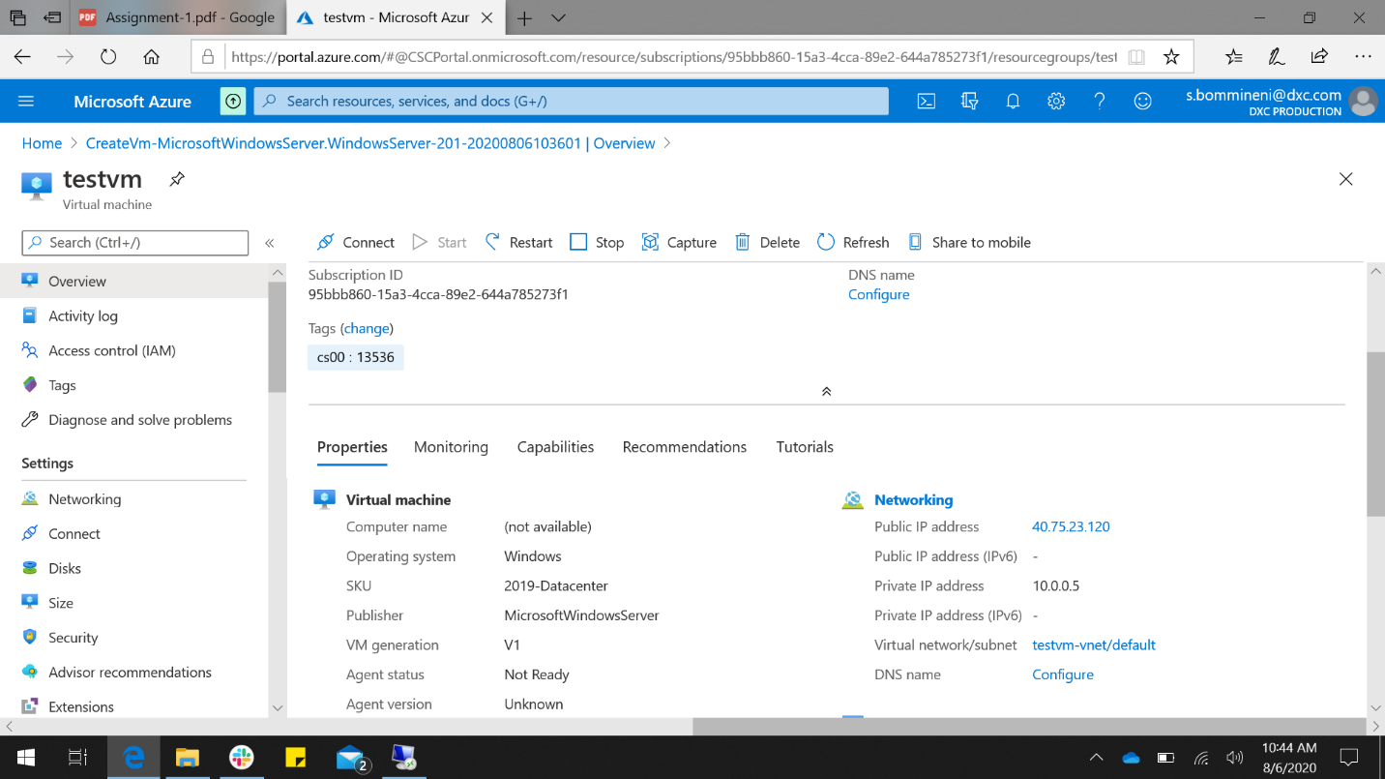

1. Attach one disk and partition into three.

I have created a disk of size 64GB and partitioned it into three (i.e E,F,G).

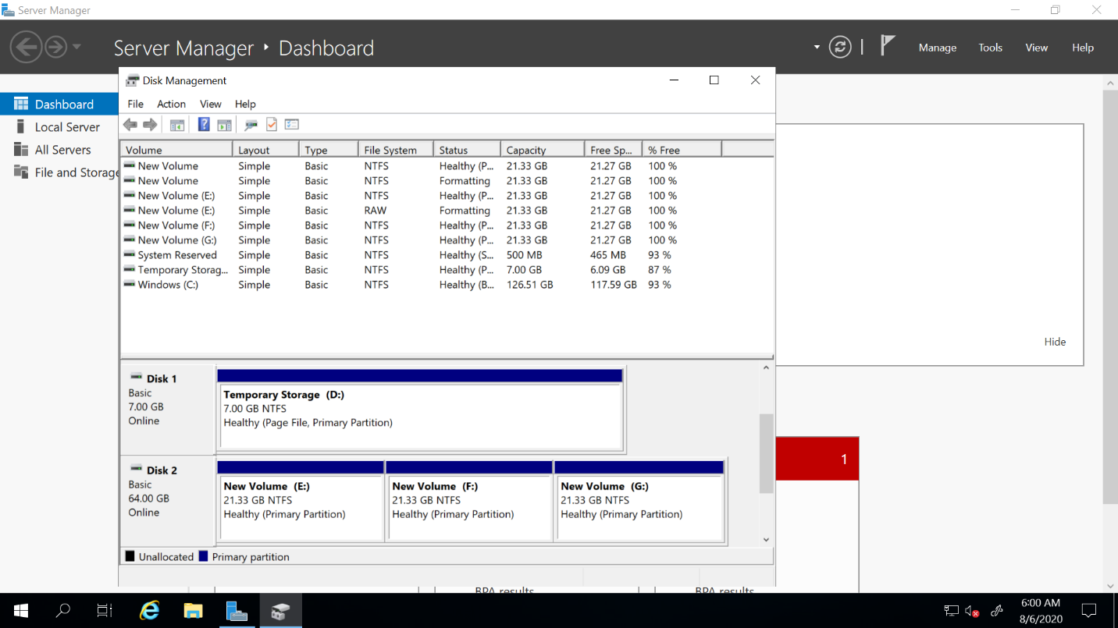

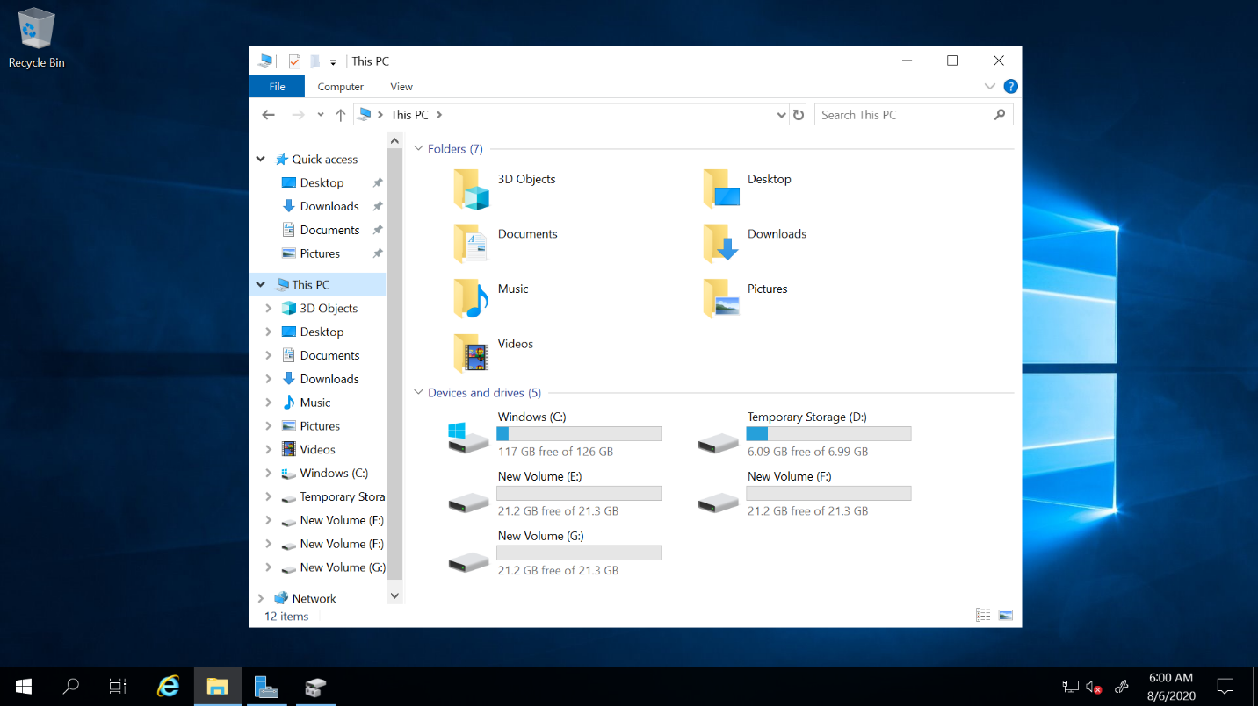

1. Auto shutdown by 5:00 PM IST and before that it should raise an alert to email.

I have set shutdown at 5:00 PM. This system will shutdown at 5:00 PM automatically everyday and before shutting down it will trigger an email to bomminenisowbhagya.lakshmi@gmail.com.

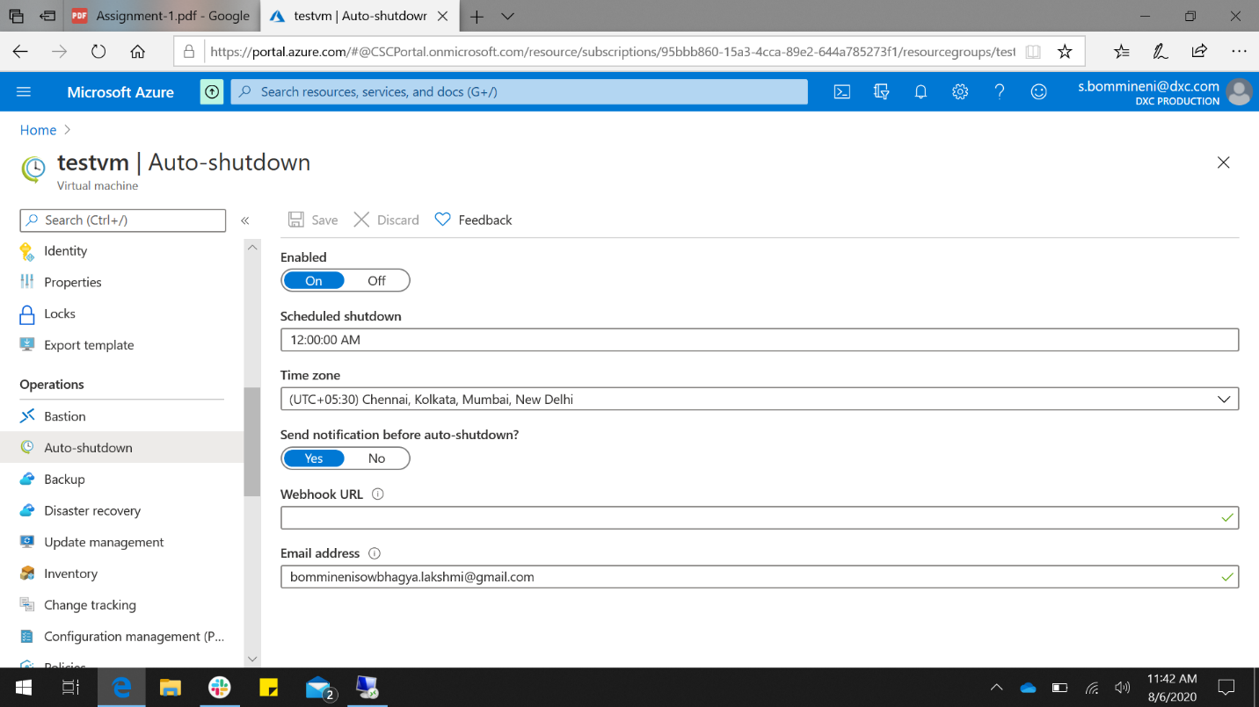

1. Install Microsoft antimalware extension in Vm.

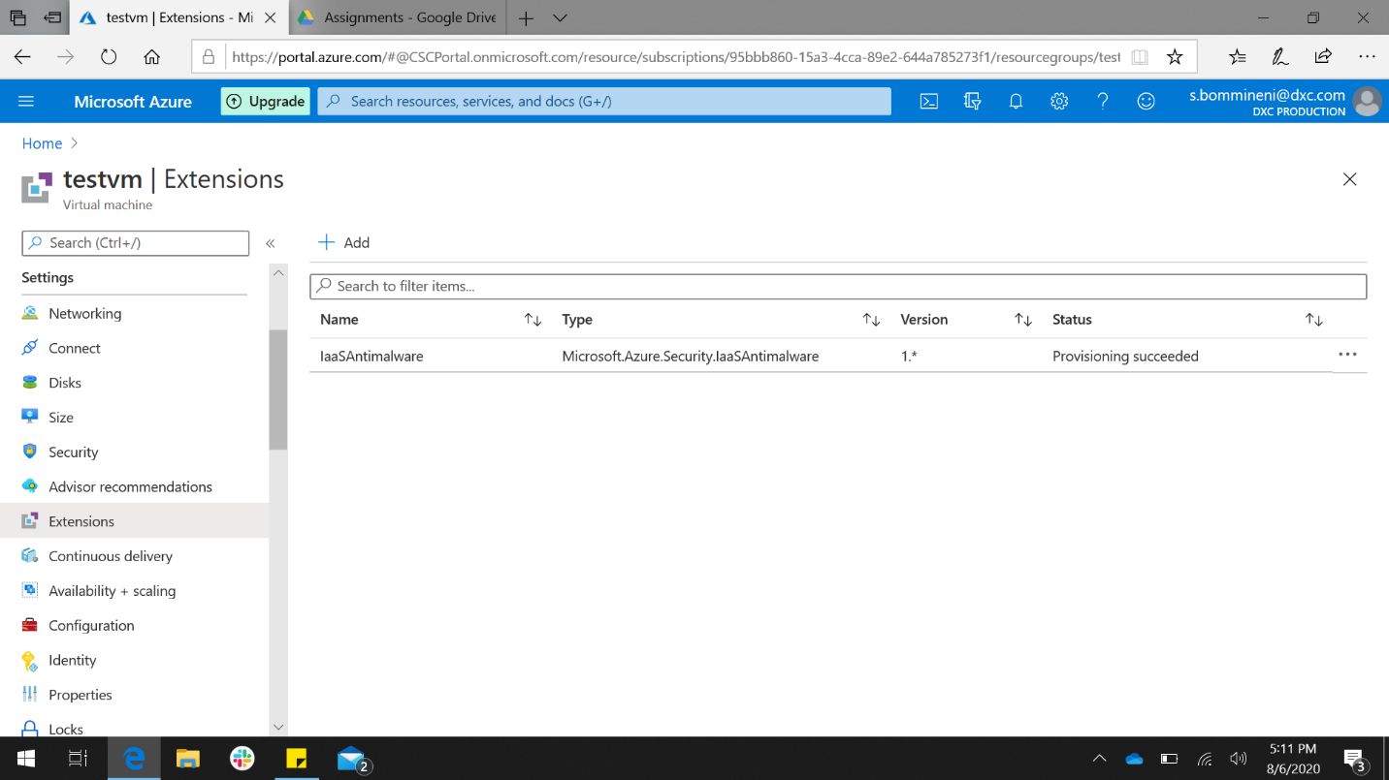

I have installed Microsoft antimalware from extensions.

1. You should be able to login to the servers with two usernames.

